**Acridine-containing RuII, OsII, RhIII and IrIII Half-Sandwich Complexes: Synthesis, Structure and Antiproliferative Activity**

Asanda C. Matsheku a, Marian Y-H. Chen b, Sandra Jordaan c, Sharon Prince c, Gregory S. Smith b and Banothile C. E. Makhubela a*

a*Department of Chemistry, University of Johannesburg, PO Box 524, Auckland Park, 2006, South Africa.*

b*Department of Chemistry, University of Cape Town, Rondebosch 7701, Cape Town, South Africa.*

c*Department of Human Biology, Division of Cell Biology, University of the Cape Town, Cape Town, South Africa.*



[M +H]+

**Figure S1:** Mass spectrum of **C1**.



[M +H]+

[M - Cl]+

**Figure S2:** Mass spectrum of **C3**.



[M +H]+

[M - Cl]+

**Figure S3:** Mass spectrum of **C2**.



[M - Cl]+

[M + H]+

**Figure S4:** Mass spectrum of **C4**.



[M - Cl]+

[M + H]+

**Figure S4a:** Mass spectrum of **C4 (zoomed-in)**.



[M]+

[(M + H)2+ + (BPh4)-]+

**Figure S5:** Mass spectrum of **C6**.



[(M + H)2+ + (BPh4)-]+

[M]+

**Figure S6:** Mass spectrum of **C7**.



[(M + H)2+ + (BPh4)-]+

[M]+

**Figure S7:** Mass spectrum of **C8**.

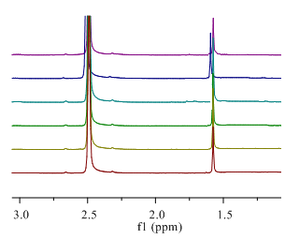

24 hours

2 hours

0.5 hours

8 hours

16 hours

0 hours

24 hours

16 hours

8 hours

2 hours

0.5 hours

0 hours

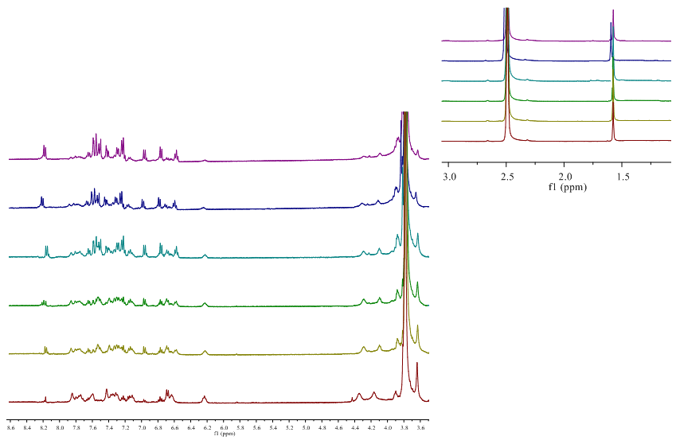

**Figure S8:** 1H NMR spectra of **C2** in DMSO-d6/D2O (50:50 v/v). Measurements were taken over 24 hours at 37 ºC.