Bis(pyrazolyl)palladium(II) complexes as catalysts for Mizoroki-Heck cross-coupling reactions
Edward Ocansey, James Darkwa* and Banothile C.E. Makhubela*
Department of Chemical Science, University of Johannesburg, Kingsway Campus, Auckland Park, 2006, South Africa.

Supplementary information

Table SI-1: Effect of temperature in Mizoroki-Heck cross-coupling reactions.
Entry | Cat. | Temp (ºC) | Conv. (%) | TON | TOF  (h⁻¹) | Selectivity (%)
 |  |  |  |  |  | trans-stilbene | cis-stilbene
1 | 5 | 80 | 21 | 43 | 11 | 88 | 12
2 | 6 | 80 | 24 | 47 | 12 | 82 | 18
3 | 7 | 80 | 15 | 29 | 7 | 86 | 14
4 | 8 | 80 | 20 | 40 | 10 | 86 | 14
5 | 5 | 100 | 68 | 135 | 34 | 85 | 15
6 | 6 | 100 | 60 | 121 | 30 | 87 | 13
7 | 7 | 100 | 69 | 137 | 34 | 85 | 15
8 | 8 | 100 | 53 | 105 | 26 | 88 | 12
9 | 5 | 120 | 72 | 144 | 36 | 86 | 14
10 | 6 | 120 | 72 | 143 | 36 | 86 | 14
11 | 7 | 120 | 75 | 151 | 38 | 87 | 13
12 | 8 | 120 | 71 | 142 | 35 | 86 | 14
13 | 5 | 130 | 100 | 200 | 50 | 87 | 13
14 | 6 | 130 | 100 | 200 | 50 | 86 | 14
15 | 7 | 130 | 100 | 200 | 50 | 85 | 15
16 | 8 | 130 | 100 | 200 | 50 | 87 | 13
17 | 5 | 140 | 100 | 200 | 50 | 82 | 18
18 | 6 | 140 | 100 | 200 | 50 | 74 | 26
19 | 7 | 140 | 100 | 200 | 50 | 78 | 22
20 | 8 | 140 | 100 | 200 | 50 | 79 | 21
Reactions carried out in DMF (1.2 mL) with 0.66 mmol of iodobenzene, 0.73 mmol of styrene, 1.32 mmol of Et₃N and 3.3×10⁻³ mmol Pd catalyst (loading= 0.5 mol%) at various temperatures and 600 rpm for 4 h. Using n-decane as internal standard. Cat. = catalyst, Conv. = conversion. Average error estimate; 5 (±0.5724), 6 (±0.5524), 7 (±0.4126), 8 (±0.4413).
Table SI-2: Base variation in Mizoroki-Heck cross-coupling reactions.
Entry | Cat. | Base | Conv. (%) | TON | TOF (h⁻¹) | Selectivity (%)
 |  |  |  |  |  | trans-stilbene | cis-stilbene
1 | 5 | KOH | 100 | 200 | 50 | 87 | 13
2 | 6 | KOH | 100 | 200 | 50 | 87 | 13
3 | 7 | KOH | 100 | 200 | 50 | 86 | 14
4 | 8 | KOH | 100 | 200 | 50 | 87 | 13
5 | 5 | K₂CO₃ | 0 | 0 | 0 | 0 | 0
6 | 6 | K₂CO₃ | 0 | 0 | 0 | 0 | 0
7 | 7 | K₂CO₃ | 0 | 0 | 0 | 0 | 0
8 | 8 | K₂CO₃ | 0 | 0 | 0 | 0 | 0
9 | 5 | Et₃N | 100 | 200 | 50 | 86 | 14
10 | 6 | Et₃N | 100 | 200 | 50 | 86 | 14
11 | 7 | Et₃N | 100 | 200 | 50 | 85 | 15
12 | 8 | Et₃N | 100 | 200 | 50 | 87 | 13
13 | 5 | C₅H₅N | 0 | 0 | 0 | 0 | 0
14 | 6 | C₅H₅N | 0 | 0 | 0 | 0 | 0
15 | 7 | C₅H₅N | 0 | 0 | 0 | 0 | 0
16 | 8 | C₅H₅N | 0 | 0 | 0 | 0 | 0
Reactions carried out in DMF (1.2 mL) with 0.66 mmol of iodobenzene, 0.73 mmol of styrene, 1.32 mmol of base and 3.3×10⁻³ mmol Pd catalyst (loading= 0.5 mol%) at 130º C and 600 rpm for 4h. Using n-decane as internal standard. Cat. = catalyst, Conv. = conversion. Average error estimate: 5 (±0.0151), 6 (±0.0245), 7 (±0.0173), 8 (±0.0291).

Table SI-3: Catalyst loading optimization for Mizoroki-Heck cross-coupling reactions.
Entry | Cat. (loading mol%) | Conv. (%) | TON | TOF (h⁻¹) | Selectivity (%)
 |  |  |  |  | trans-stilbene | Cis-stilbene
1 | 5 (0.38) | 100 | 267 | 67 | 85 | 15
2 | 6 (0.38) | 100 | 267 | 67 | 87 | 13
3 | 7 (0.38) | 100 | 267 | 67 | 87 | 13
4 | 8 (0.38) | 100 | 267 | 67 | 87 | 13
5 | 5 (0.25) | 100 | 400 | 100 | 86 | 14
6 | 6 (0.25) | 100 | 400 | 100 | 88 | 12
7 | 7 (0.25) | 100 | 400 | 100 | 87 | 13
8 | 8 (0.25) | 100 | 400 | 100 | 86 | 14
9 | 5 (0.13) | 100 | 800 | 200 | 85 | 15
10 | 6 (0.13) | 100 | 800 | 200 | 84 | 16
11 | 7 (0.13) | 100 | 800 | 200 | 85 | 15
12 | 8 (0.13) | 100 | 800 | 200 | 87 | 13
13 | 5 (0.0625) | 100 | 1600 | 400 | 89 | 11
14 | 6 (0.0625) | 100 | 1600 | 400 | 88 | 12
15 | 7 (0.0625) | 100 | 1600 | 400 | 87 | 13
16 | 8 (0.0625) | 100 | 1600 | 400 | 88 | 12
17 | 5 (0.0375) | 97 | 2586 | 646 | 90 | 10
18 | 6 (0.0375) | 99 | 2629 | 657 | 90 | 10
19 | 7 (0.0375) | 96 | 2565 | 641 | 90 | 10
20 | 8 (0.0375) | 94 | 2516 | 629 | 90 | 10
21 | 5 (0.0094) | 52 | 5605 | 1401 | 89 | 11
22 | 6 (0.0094) | 53 | 5671 | 1418 | 89 | 11
23 | 7 (0.0094) | 54 | 5858 | 1464 | 89 | 11
24 | 8 (0.0094) | 45 | 4891 | 1223 | 89 | 11
25 | 5 (0.00625) | 20 | 3177 | 794 | 96 | 4
26 | 6 (0.00625) | 18 | 2910 | 728 | 94 | 6
27 | 7 (0.00625) | 20 | 3189 | 797 | 94 | 4
28 | 8 (0.00625) | 23 | 3612 | 903 | 95 | 5
Reactions carried out in DMF (1.2 mL) with 1.0 eq of iodobenzene, 1.1 eq of styrene, 2.0 eq of Et₃N and varied Pd catalyst loading at 130º C and 600 rpm for 4h. Using n-decane as internal standard. Cat. = catalyst, Conv. = conversion. Average error estimate; 5 (±0.3323), 6 (±0.2235), 7 (±0.3855), 8 (±0.3412)
Table SI-4: Conversion as a function of time in Mizoroki-Heck cross-coupling reactions.
Entry | Cat. | Time (h) | Conv. (%) | TON | TOF  (h⁻¹) | Selectivity (%)
 |  |  |  |  |  | trans-stilbene | cis-stilbene
1 | 5 | 0.5 | 27 | 1437 | 718 | 90 | 10
2 | 6 | 0.5 | 55 | 2929 | 1465 | 90 | 10
3 | 7 | 0.5 | 57 | 1507 | 3015 | 89 | 11
4 | 8 | 0.5 | 74 | 1970 | 3939 | 89 | 11
5 | 5 | 1 | 72 | 1927 | 1927 | 89 | 11
6 | 6 | 1 | 80 | 2146 | 2146 | 89 | 11
7 | 7 | 1 | 85 | 2272 | 2272 | 89 | 11
8 | 8 | 1 | 90 | 2393 | 2393 | 87 | 13
9 | 5 | 1.5 | 90 | 2394 | 1596 | 88 | 12
10 | 6 | 1.5 | 94 | 2497 | 1665 | 88 | 12
11 | 7 | 1.5 | 94 | 2513 | 1675 | 89 | 11
12 | 8 | 1.5 | 90 | 2393 | 1596 | 90 | 10
13 | 5 | 2 | 90 | 2412 | 1206 | 91 | 9
14 | 6 | 2 | 96 | 2560 | 1280 | 89 | 11
15 | 7 | 2 | 94 | 2513 | 1257 | 90 | 10
16 | 8 | 2 | 93 | 2490 | 1245 | 90 | 10
17 | 5 | 3 | 94 | 2508 | 836 | 88 | 12
18 | 6 | 3 | 97 | 2597 | 866 | 90 | 10
19 | 7 | 3 | 98 | 2604 | 868 | 89 | 11
20 | 8 | 3 | 95 | 2525 | 842 | 87 | 13
21 | 5 | 4 | 97 | 2586 | 646 | 90 | 10
22 | 6 | 4 | 99 | 2629 | 657 | 90 | 10
23 | 7 | 4 | 96 | 2565 | 641 | 90 | 10
24 | 8 | 4 | 94 | 2516 | 629 | 90 | 10
Reactions carried out in DMF (1.2 mL) with 26.4 mmol of iodobenzene, 29.04 mmol of styrene, 52.8 mmol of Et₃N and 3.3×10⁻³ mmol Pd catalyst (loading= 0.0375 mol%) at 130 ºC and 600 rpm for varied reaction periods. Using n-decane as internal standard. Cat. = catalyst, Conv. = conversion. Average error estimate; 5 (±0.2276), 6 (±0.3321), 7 (±0.2988), 8 (±0.3231)

Table SI-5: Mercury poisoning test in Mizoroki-Heck cross-coupling reactions with (pre)catalysts 8-11
Entry | Cat. | Amount of Hg (mg) | Conv.  (%) | TON | TOF  (h⁻¹) | Selectivity (%)
 |  |  |  |  |  | trans-stilbene | cis-stilbene
1 | 5 | 0 | 100 | 200 | 50 | 87 | 13
2 | 6 | 0 | 100 | 200 | 50 | 86 | 14
3 | 7 | 0 | 100 | 200 | 50 | 85 | 15
4 | 8 | 0 | 100 | 200 | 50 | 87 | 13
5 | 5 | 1 | 100 | 200 | 50 | 89 | 11
6 | 6 | 1 | 100 | 200 | 50 | 87 | 13
7 | 7 | 1 | 100 | 200 | 50 | 88 | 12
8 | 8 | 1 | 100 | 200 | 50 | 86 | 14
9 | 9 | 0 | 100 | 200 | 50 | 89 | 11
10 | 9 | 1 | 100 | 200 | 50 | 89 | 11
Reactions carried out in DMF (1.2 mL) with 0.66 mmol of iodobenzene, 0.73 mmol of styrene, 1.32 mmol of Et₃N and 3.3×10⁻³ mmol Pd catalyst (loading= 0.5 mol%) at 130 ºC and 600 rpm for 4 h. Using n-decane as internal standard Cat. = catalyst, Conv. = conversion. Average error estimate; 5 (±0.2264), 6 (±0.2817), 7 (±0.3100), 8 (±0.2977), 9 (±0.3342)

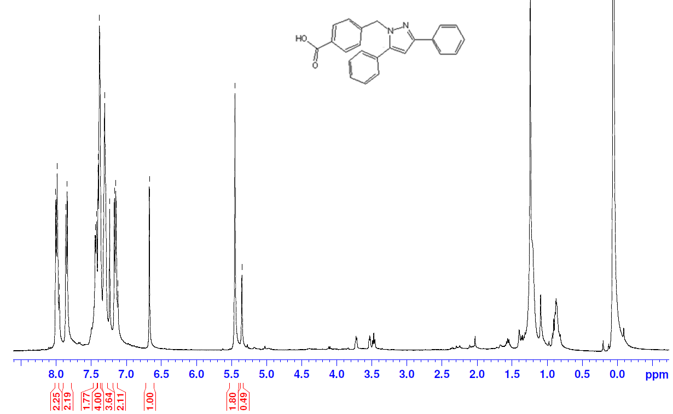
Figure SI-1: ¹HNMR spectrum of 1a, recorded in CDCl₃.
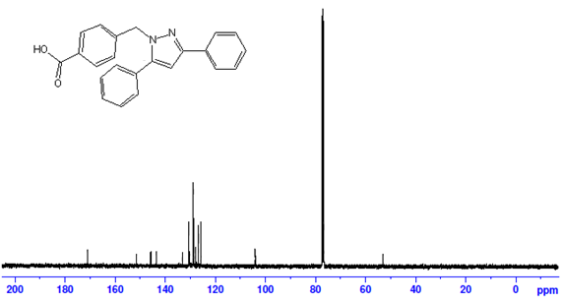
Figure SI-2: ¹³C{¹H} NMR spectrum of 1a, recorded in CDCl₃.

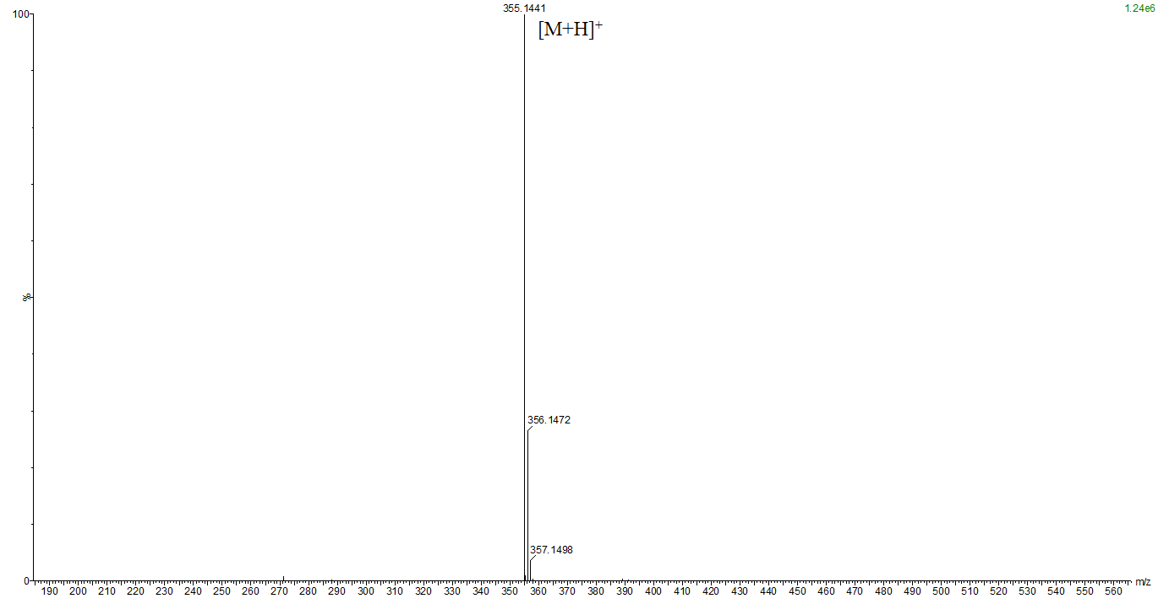
Figure SI-3: Mass spectrum of 1a

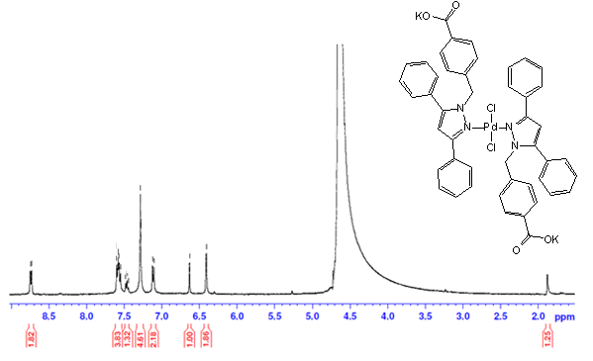
Figure SI-4: ¹H NMR spectrum of complex 9+KOH, recorded in D₂O.

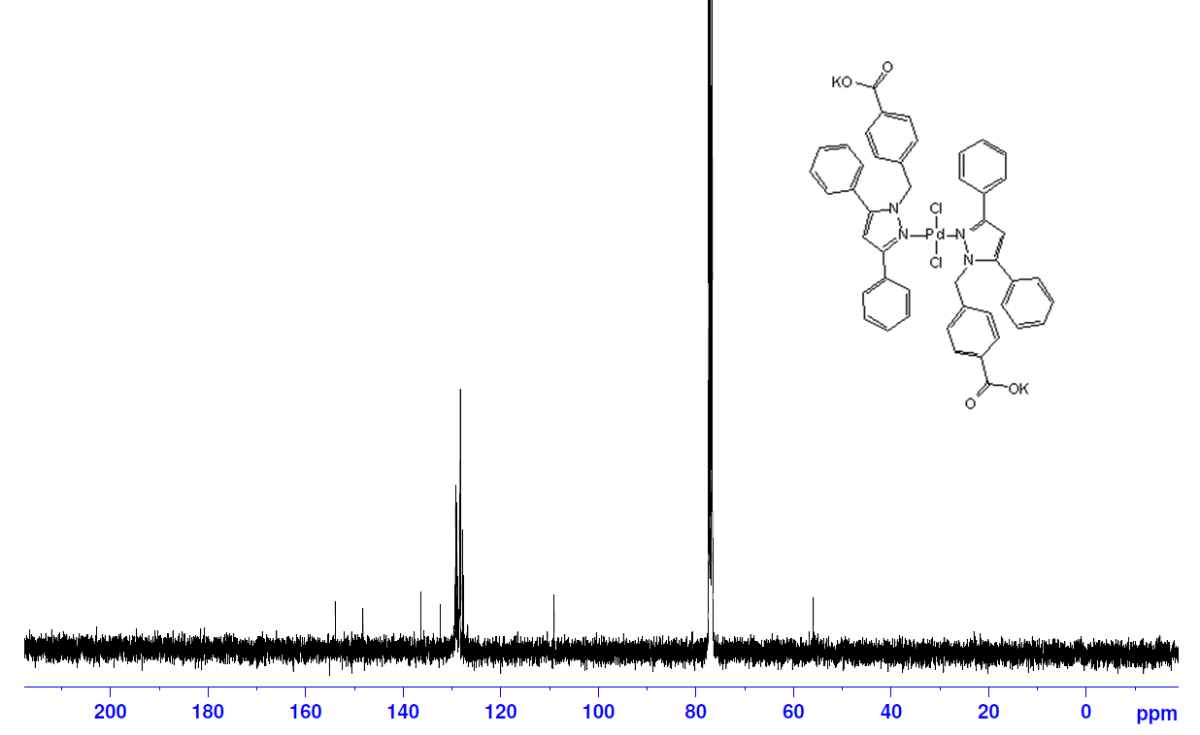

Figure SI-5: ¹³C{¹H} spectrum of complex 9+KOH, recorded in CDCl₃.

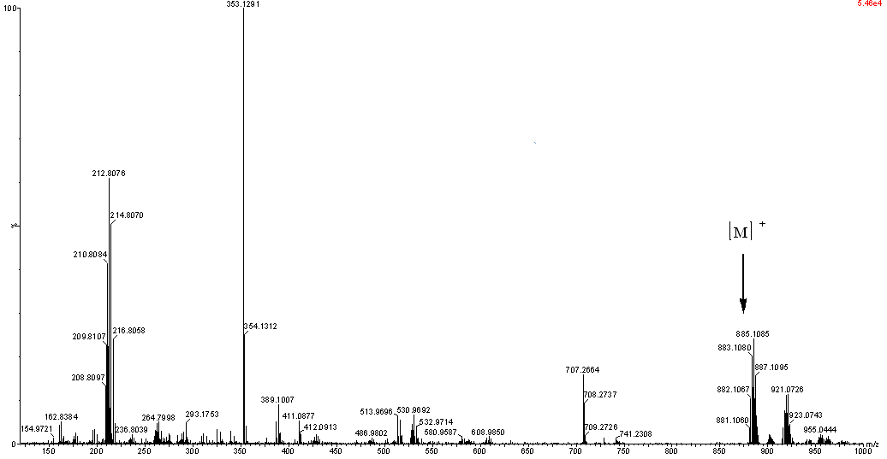

Figure SI-6: Mass spectrum of 9

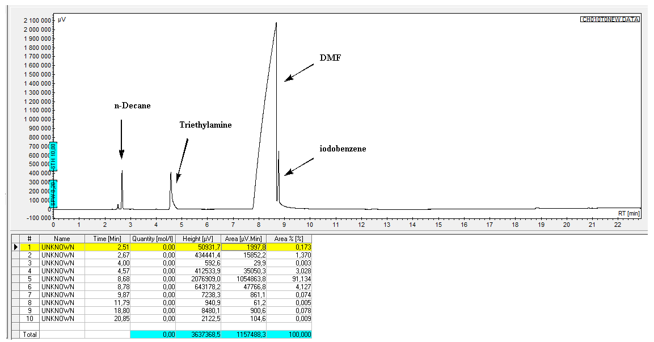
Figure SI-7: Representative Gas chromatogram before Mizoroki-Heck cross-coupling reaction.

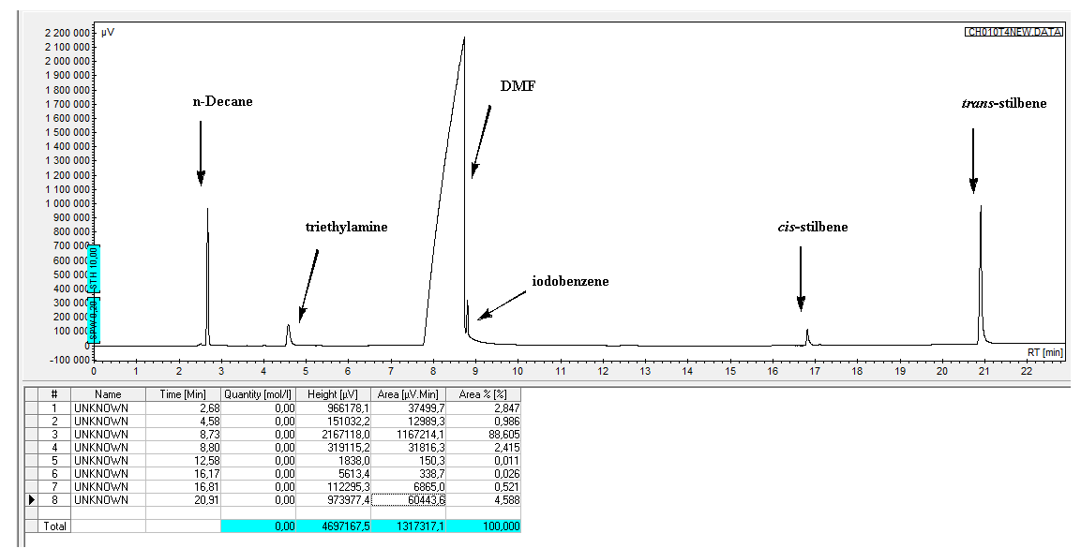
Figure SI-8: Representative gas chromatogram after Mizoroki-Heck cross-coupling reaction

