**SUPPLEMENTARY INFORMATION**

# **Rhodium(I) metallacycles based on alkylated-PTA scaffolds: Synthesis and evaluation as hydroformylation catalyst precursors**

Diteboho S. Ramaroua, Banothile C.E. Makhubelab, Gregory S. Smith\*a

*a Department of Chemistry, University of Cape Town, Rondebosch, 7701, South Africa*

*b Department of Chemistry, University of Johannesburg, PO Box 524, Auckland Park, 2006, South Africa*

C:\Users\AbongaDeeTee\AppData\Local\Microsoft\Windows\INetCacheContent.Word\1,4-mononuclear_numbered.tifC:\Users\AbongaDeeTee\AppData\Local\Microsoft\Windows\INetCacheContent.Word\1,4-mononuclear_H NMR.TIFF

**Figure 1:** 1H NMR spectrum of the 1,4-mononuclear Rh(I)-PTA complex (**4**).

C:\Users\AbongaDeeTee\AppData\Local\Microsoft\Windows\INetCacheContent.Word\1,4-mononuclear_P NMR.TIFF

**Figure 2:** 31P NMR spectrum of the 1,4-mononuclear Rh(I)-PTA complex (**4**).



**Figure 3:** 13C NMR spectrum of the 1,4-mononuclear Rh(I)-PTA complex (**4**).

**Figure 4:** FT-IR spectrum of the 1,4-mononuclear Rh(I)-PTA complex **4**.

Acetone

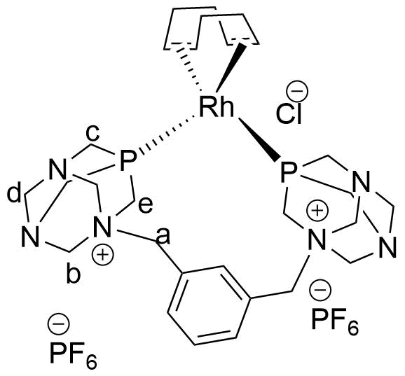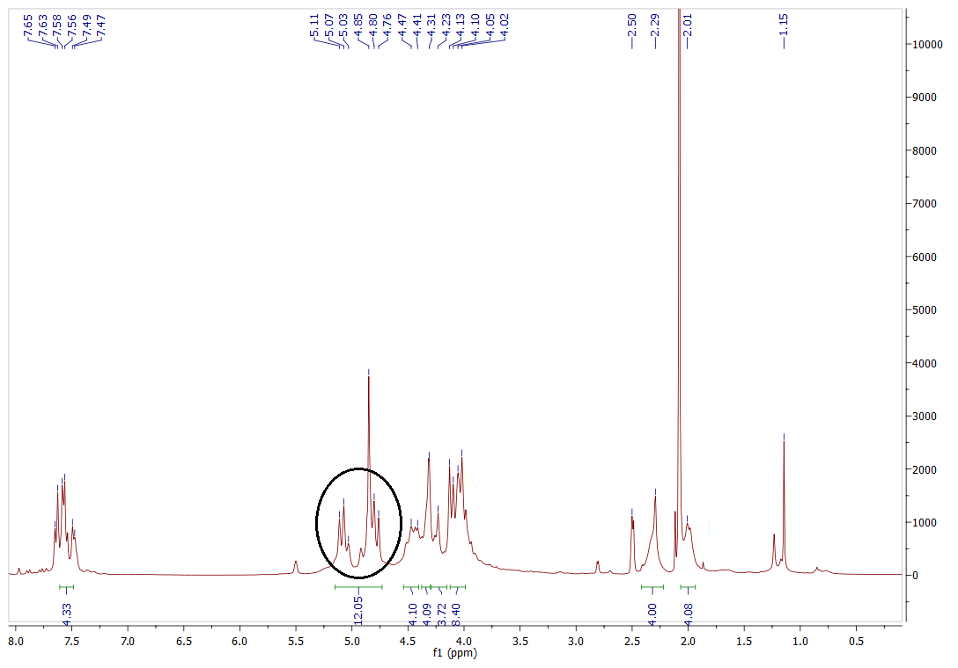

b, d

c

DMSO-*d6*

HCOD

HCOD

HCOD

ArH

a

e

**Figure 5:** 1H NMR spectrum (DMSO-*d6*) for complex **5**.



PF6

*J*Rh-P = 125.6 Hz

**Figure 6:** 31P NMR spectrum (DMSO-*d6*) for complex **5**.



**Figure 7:** 13C NMR spectrum (DMSO-*d6*) for complex **5**.

**Figure 8:** FT-IR spectrum of complex **5**.

**Figure 9:** FT-IR spectrum of complex **6**.

**Figure 10:** FT-IR spectrum of complex **7**.

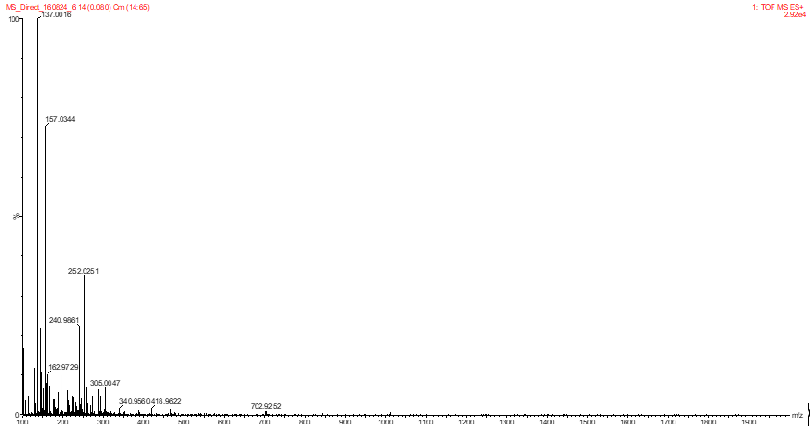

**Figure 11:** Mass spectrum of complex 4.

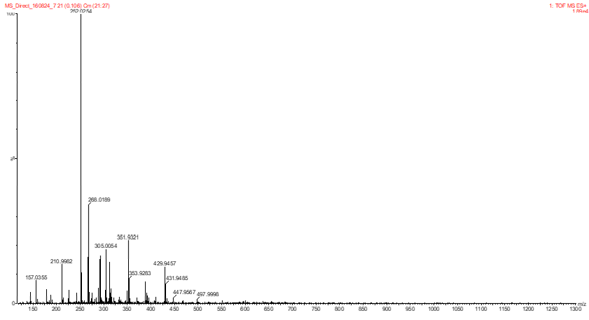

**Figure 12:** Mass spectrum of complex **5**.

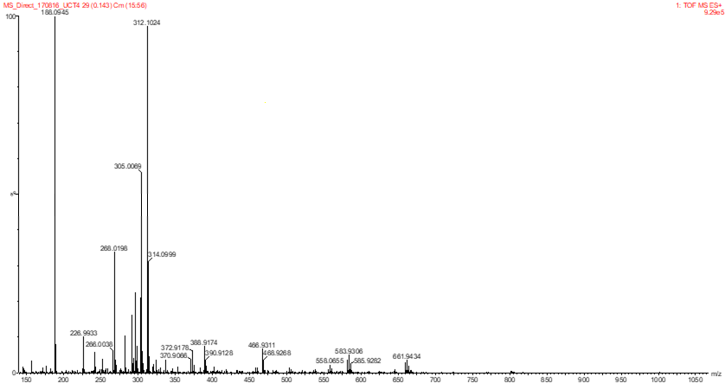

**Figure 13:** Mass spectrum of complex **6**.

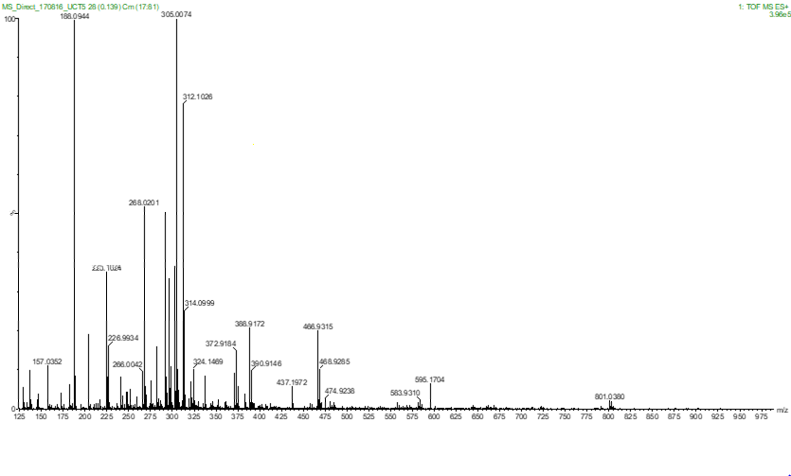

**Figure 14:** Mass spectrum of complex **7**.