# 8. Supplementary material

8.1. Preparation of L1[1]

In a 250 mL round-bottomed flask containing a stirring solution of 2-hydroxy-1-naphthaldehyde (312 mg, 1.81 mmol) and formic acid (0.0700 mL, 1.81 mmol) in hot methanol (50.0 mL), 2-aminonaphthalene (259 mg, 1.81 mmol) was added. The reaction was stirred under reflux for 8 h to afford a reaction mixture with an orange precipitate. The reaction solvent was reduced by rotary evaporation and the mixture was transferred to a Schlenk tube containing hexane (50.0 mL) and the resulting two layers were vigorously stirred at room temperature for 15 min. The orange suspension was filtered by gravity, washed with cold methanol (15.0 mL), and dried under high vacuum to afford **L1** as an orange solid.



**L1**: orange solid, Yield: 353 mg (66.0%). **FT-IR**: ATR, *v*/cm-1: 3030 – 3031 (br, naphtha Csp2–H stretch), 1643 - 1618 (signal overlap, C-H out of plane bending mode), 1610 (s, **N=CH**, imine), 1538 (naphtha Csp2=Csp2 stretch), 1306 (s, C-N, stretch), 965 – 461 (C-H in-plane bending vibrations). **1H NMR** (400 MHz, (CDCl3): δH (ppm) =7.10 (d, 1H, *3J* = 10 Hz, H3), 7.34(t, 1H, *3J* = 7.5 Hz, H6), 7.48 (t, 1H, *3J* = 7.5 Hz, H7), 7.54 – 7.56 **(**m, 3H,H3’, H6’ and H7’), 7.71 (d, 1H, *3J* = 8.0 Hz, H5), 7.73 (s, 1H, H1’), 7.79 (d, 1H, *3J* = 9.1 Hz, H4), 7.85 – 7.88 (m, 2H, H5’ and H8’), 7.91 (d, 1H, *3J* = 9.1 Hz, H4’), 8.12 (d, 1H, *3J* = 8.4 Hz, H8), 9.42 (s, 1H, N=C**H**), 15.63 (s, 1H, O**H**).**13C{1H} NMR** (100 MHz, (CDCl3): δC (ppm) = 109.04 (C-1), 117.58 (C-1’), 118.94 (C-8), 119.64 (C-3’), 122.33 (C-3), 123.57 (C-6), 125.88 (C-7), 126.96 (C-6’ and C-7’), 127.37 (C-10), 127.86 (C-8’), 128.11 (C-5’), 129.41 (C-5), 129.69 (C-4’), 132.06 (C-10’), 133.30 (C-9), 134.02 (C-9’), 136.75 (C-4), 142.74 (C-2’), 154.50 (N=**C**H), 170.48 (C-2). **Elemental analysis** (%): Calculated for C21H15NO (297.1154): C, 84.82; H, 5.08; N, 4.71; Found: C, 84.63; H, 5.00; N, 4.41. Melting point = 148.3 – 149.1 ˚C (lit. 149 ˚C)[2]

8.2. 13C{1H} NMR spectrum of **L1** in CDCl3



* 1. 13C{1H} NMR spectrum of *N,O*-Ru(II) (**C1**) in CDCl3

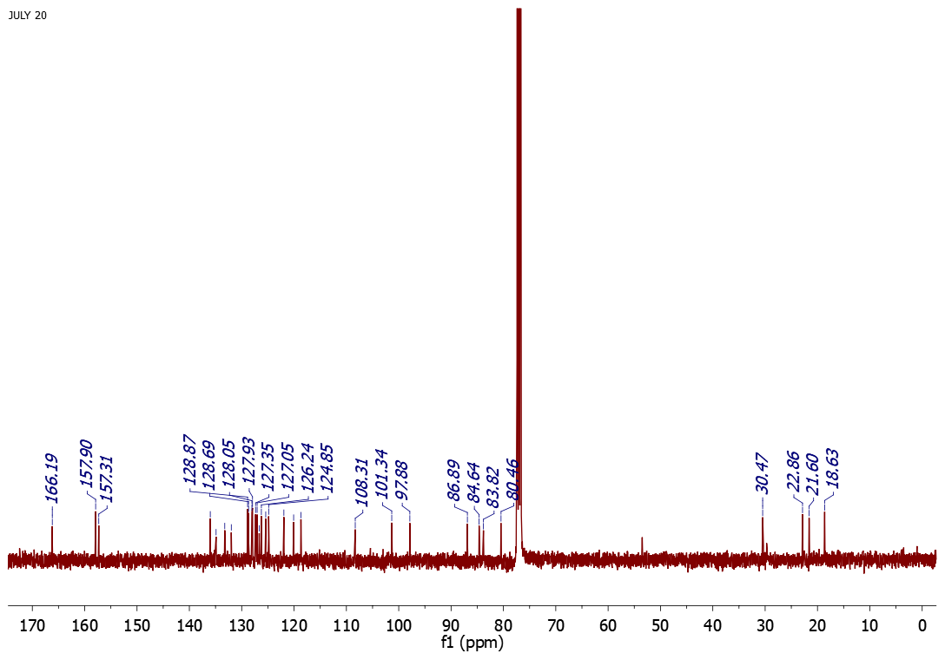

DCM

8.4. 1H NMR Spectrum of *N,O*-Os(II)(**C2**)in CDCl3

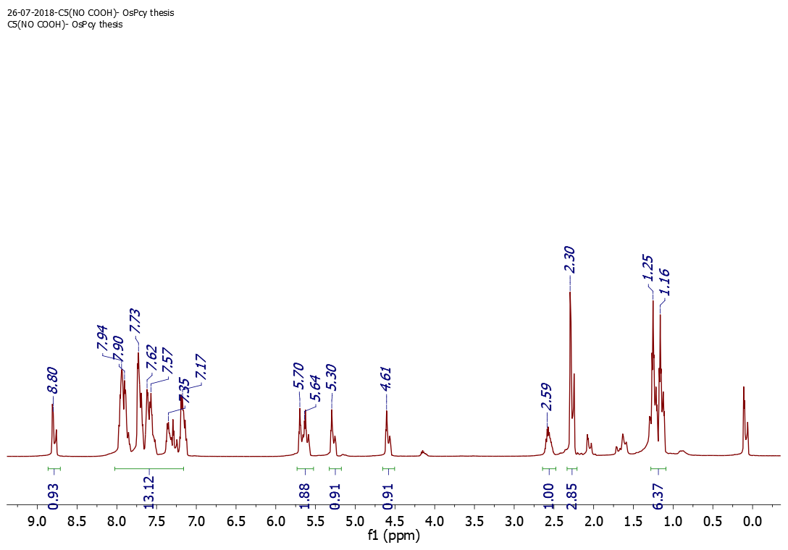

EtOAc

EtOAc

8.5. 13C{1H} NMR Spectrum of *N,O*-Os(II)(**C2**)in CDCl3

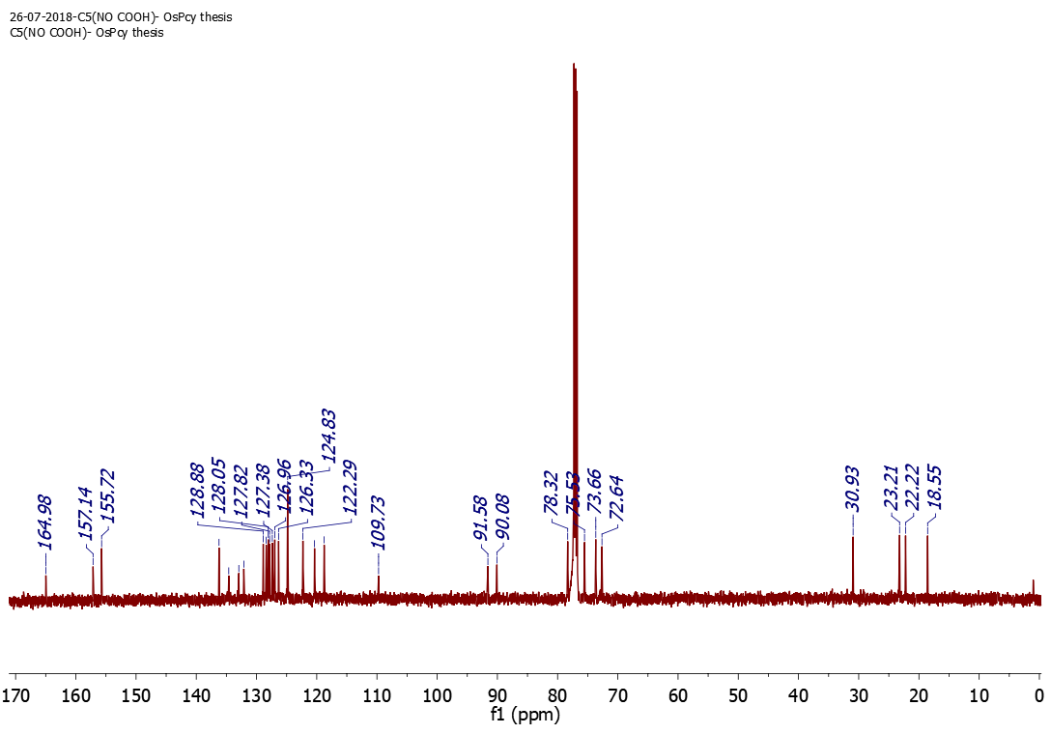

* 1. 1H NMR Spectrum of *N,O*-Rh(III)(**C3**) in CDCl3

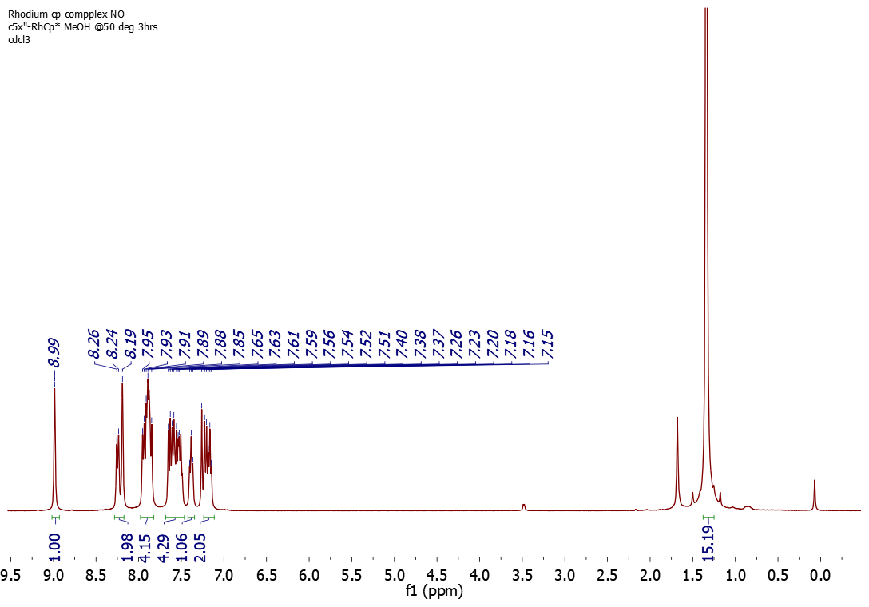

8.7. 13C{1H} NMR Spectrum of *N,O*-Rh(III)(**C3**) in CDCl3

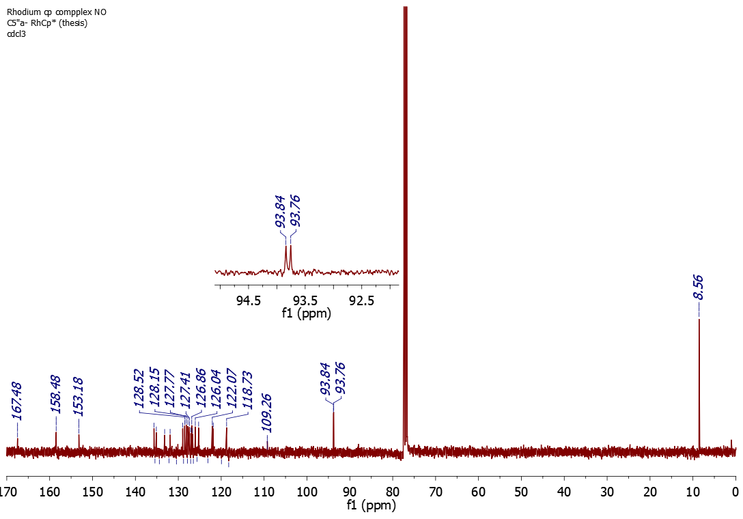

* 1. 1H NMR Spectrum of *N,O*-Ir(III)(**C4**) in CDCl3

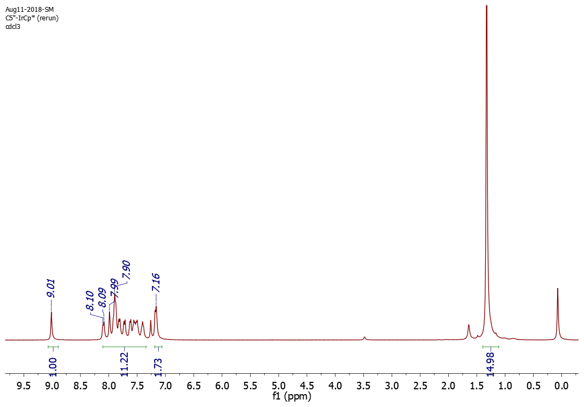

* 1. 13C{1H} NMR of *N,O*-Ir(III)(**C4**) in CDCl3



* 1. Mass spectra of **C1 – C4**



**C1**



**C2**



**C3**



**C4**

* 1. 1H NMR spectrum of [DBUH][HCO2] from direct CO2 hydrogenation experiments.

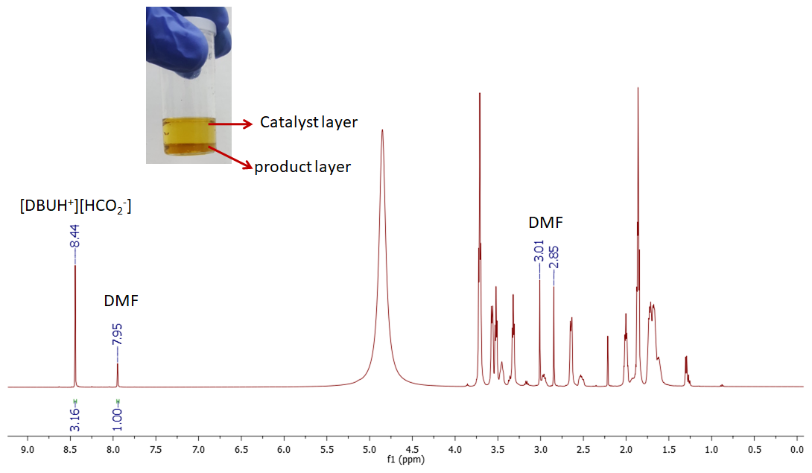

FIGURE S1: 1H NMR spectrum for direct CO2 hydrogenation by 8.83 µmol C4. Reaction conditions (a) DBU = 4.00 mmol, CO2/H2 (1:2) = 60 bar, THF/H2O = 6.00 mL, T = 120 ºC, t = 48 h. NMR internal standard: 10.0 µL *N*-dimethyl formamide (1H NMR formyl proton signal at 7.95 ppm, 13C NMR carbonyl carbon signal at 165.53 ppm).

* 1. 1H NMR spectrum of [DBUH][HCO2] from direct CO2 hydrogenation experiments.

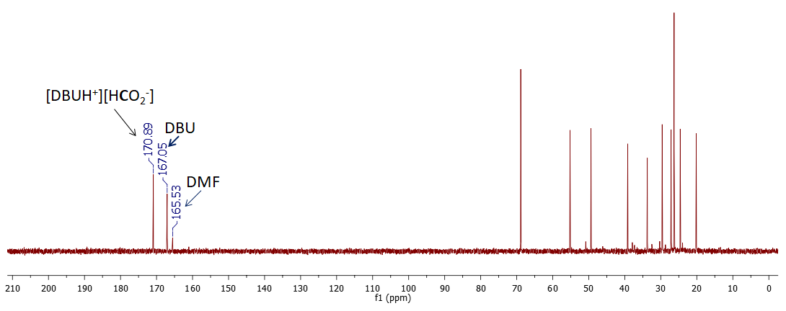

FIGURE S2: 1H NMR spectrum for direct CO2 hydrogenation by 8.83 µmol C4. Reaction conditions (a) DBU = 4.00 mmol, CO2/H2 (1:2) = 60 bar, THF/H2O = 6.00 mL, T = 120 ºC, t = 48 h. NMR internal standard: 10.0 µL *N*-dimethyl formamide (1H NMR formyl proton signal at 7.95 ppm, 13C NMR carbonyl carbon signal at 165.53 ppm).

* 1. Characterization of indirect CO2 products.

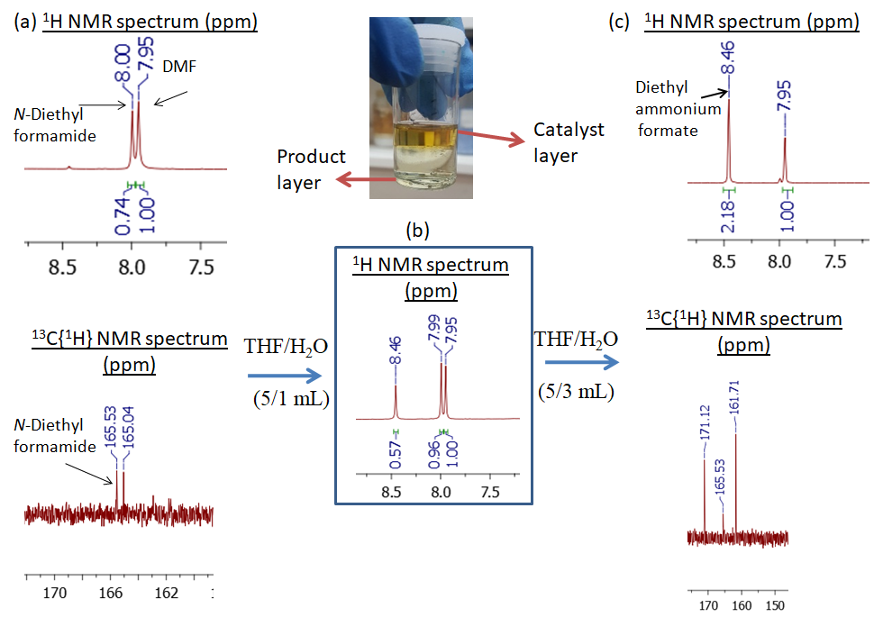

FIGURE S3:1H NMR spectrum for indirect CO2 hydrogenation by 8.83 µmol C4. NMR internal standard: 10.0 µL *N*-dimethyl formamide (1H NMR formyl proton signal at 7.95 ppm, 13C{1H} NMR carbonyl carbon signal at 165.53 ppm).

[1] Ö. Tamer, N. Dege, G. Demirtaş, D. Avci, Y. Atalay, M. Macit, A.A. Aǧar, An experimental and theoretical study on the novel (Z)-1-((naphthalen-2- ylamino)methylene)naphthalen-2(1H)-one crystal, Spectrochim. Acta A Mol. Biomol. Spectrosc. 117 (2014) 13–23. https://doi.org/10.1016/j.saa.2013.07.098.

[2] Y. Zhang, B. Shi, P. Zhang, J. Huo, P. Chen, Q. Lin, J. Liu, T. Wei, A highly selective dual-channel Hg2+ chemosensor based on an easy to prepare double naphthalene Schiff base, Sci. China Chem. 56 (2013) 612–618. https://doi.org/10.1007/s11426-012-4798-0.